Discovery 4: Tuning STP and Configuring RSTP

Overview
In this discovery, there are two loops in this topology: SW1-SW2-SW3 and SW2-SW3. The network has been wired in such a way that it provides redundancy. But, Layer 2 loops will also occur in this topology if STP does not block redundant links.
STP has been preconfigured on the switches. You will first explore the STP configurations on the switches and then tune the configuration by manipulating priority, cost, and timers in STP.
You will also observe the differences between STP and RSTP configurations and convergence time.
Following are the tasks that you will perform in the lab:
- Explore the Spanning Tree Protocol configuration on switches.
- Tuning STP configuration.
- Configure RSTP on switches.
Task 1: Explore Spanning Tree Protocol Configuration on Switches

Activity

Step 1: Issue the show spanning-tree command on all three switches (SW1, SW2, and SW3) and identify which switch is the root bridge.
On SW1, SW2, and SW3, enter the following commands:
SW3# show spanning-tree

SW2# show spanning-tree
SW1# show spanning-tree

SW1 is the root bridge. All three switches have the same priority, so the switch with the lowest MAC address is elected as the root bridge.

Note
The device's MAC addresses can be different in your outputs.

Step 2: Use the show spanning-tree command on all three switches (SW1, SW2, and SW3) and investigate the port roles.
On SW1, SW2, and SW3, enter the following commands:

SW1# show spanning-tree
SW2# show spanning-tree
SW3# show spanning-tree
Since SW1 is the root bridge, it has both of its connected ports in designated (forwarding) state.

Because SW2 and SW3 are not the root bridge, only 1 port must be elected root on each of these two switches. The root port is the port with the lowest cost to the root bridge. As SW3 has a lower BID than SW2, all ports on SW3 are set to designated. Other ports on SW2 are nondesignated.

Note
The Cisco proprietary protocol PVST+ uses the term "alternate" for nondesignated ports.

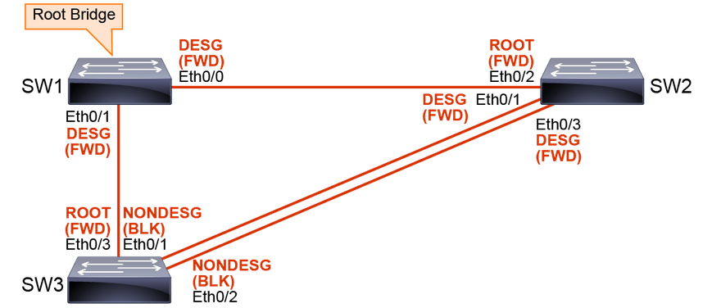

Task 2: Tuning STP Configuration on Switches

Changing STP Priority
You do not want the network to choose the root bridge by itself. If all switches have default STP priorities, the switch with the lowest MAC address will become the root bridge. The oldest switch will have the lowest MAC address, since the lower MAC addresses were factory-assigned first. To manually set the root bridge, you can change the priority of the switch.

There are two ways of changing switch priority:
Setting the exact value. The value must be between 0 and 65,535 and in increments of 4096. spanning-tree vlan vlan-id priority bridge-priority
Setting the primary root bridge with a macro. Use the spanning-tree vlan vlan-id root primary command.
spanning-tree vlan vlan-id root primary

When changing the priority, you must set the correct values. The priority can be a value between 0 and 61,440 in increments of 4096. The default value is 32,768. With PVST, the extended system ID is used for calculating bridge priority. The priority reduces from 16 to 4 bits, as 12 bits represent the VLAN ID. With a 4-bit priority, there are 16 total combinations. For example, an increment value of 15 becomes a priority value of 61,440 (4096 x 15). You cannot change the priority from 32,768 to 32,789. Instead, you must add a multiple of 4096, so the next possible priority value would be 36,864.

The better solution is to use the spanning-tree vlan vlan-id root {primary | secondary} command. This command is a macro that lowers the switch priority number in order for it to become the root bridge.

To configure the switch to become the root bridge for a specified VLAN, use the primary keyword. Use the secondary keyword to configure a secondary root bridge. If the primary root bridge fails, you do not want the slowest, oldest access-layer switch becoming the root bridge.

If the current root priority is more than 24,576, the local switch sets its priority to 24,576. If the root bridge has a priority lower than 24,576, then the local switch sets its priority to 4096 less than the value of the current root bridge. Configuring the secondary root bridge sets a priority of 28,672. There is no way for the switch to figure out what the second-best priority is in the network, so setting the secondary priority to 28,672 is just a best guess.

If you issue the show running-configuration command, you will see the switch priority as a number—not the primary or secondary keyword.

Note
If the priority of the root bridge is set to 0, configuring another switch with the root primary command will yield no results. The command will fail since it cannot make a local switch priority for 4096 lower than the priority of the root bridge.

You can display the status of the root bridge using the show spanning-tree root command.

Activity

Step 1: Configure and verify SW2 as the root bridge for VLAN 1.
On SW2 switch, enter the following commands:
SW2(config)# spanning-tree vlan 1 root primary

Verify that SW2 is now the root bridge for VLAN 1.
SW2# show spanning-tree
Since SW1 is the root bridge, all its ports will be in the designated state, or forwarding. SW1 and SW3 have changed port roles according to the change of the root bridge.

Step 2: Use the show spanning-tree command on SW1 and SW3 to observe the changed port roles.
On SW1 and SW3 switches, enter the following commands:
SW1# show spanning-tree
Port roles after configuring SW2 as the root bridge look like the following.

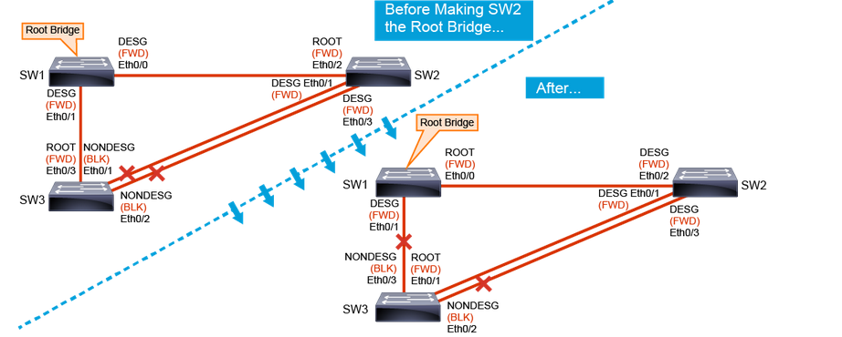

STP Path Manipulation

For port role determination, the cost value is used. If all ports have the same cost, the sender Port_ID breaks the tie. To control active port selection, you can change the cost of the interface or the sender interface Port_ID.
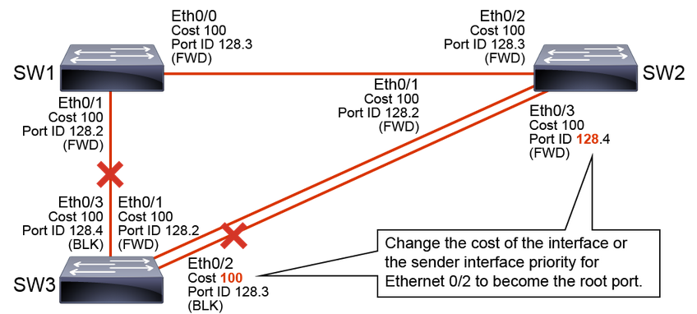
You can modify port cost using the spanning-tree vlan vlan-list cost cost-value command. The cost value can be between 1 and 65,535.

The Port_ID consists of the port priority and port number. As the port number is fixed, because it is based only on its hardware location, you can change the Port_ID by configuring the port priority.
You could also modify the port priority using the spanning-tree vlan vlan-list port-priority port-priority command. The value of the port priority can be between 0 and 255; the default is 128. A lower port priority means a more preferred path to the root bridge.

In the given example, GigabitEthernet 0/1 and GigabitEthernet 0/2 have the same interface STP cost. GigabitEthernet 0/1 is forwarding because its sender Port_ID (128.2) is lower than that of GigabitEthernet 0/2 (128.4). 1 way that you could make SW3 GigabitEthernet 0/2 forwarding is to lower the port cost on GigabitEthernet 0/2. Another way to make SW3 GigabitEthernet 0/2 forwarding is to lower its sender port priority. In this case, this adjustment is done to the port GigabitEthernet 0/3 on SW2.

Step 3: Configure GigabitEthernet 0/2 on SW3 as the root port by changing its cost.
Right now, GigabitEthernet 0/1 is the root port on SW3. GigabitEthernet 0/1 is forwarding because its sender Port_ID (128.2) is lower than that of GigabitEthernet 0/2 (128.4). Since you will change the cost of SW3's interface, the sender interface port priority will no longer be observed. STP checks port priority only when costs are equal.
On SW3 switch, enter the following commands:
SW3(config)# interface GigabitEthernet 0/2
SW3(config-if)# spanning-tree vlan 1 cost 1
Step 4: Using the show spanning-tree command, investigate the STP port roles on SW1 and SW3.
Because interface GigabitEthernet 0/2 now has a lower cost, it is assigned as the root port. STP reconsiders a new path, so new port roles are assigned on SW1 and SW3. Since SW2 is the root bridge, it will have all ports that are designated, or forwarding.
On SW1 and SW3 switches, enter the following commands:

SW1# show spanning-tree

SW3#show spanning-tree

Port roles after manually configuring root port on SW3 appear as follows.

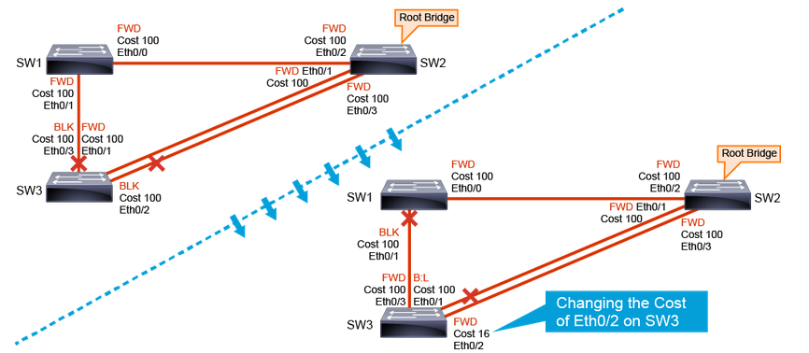

Step 5: Turn on the STP topology events debugging on SW3.
You have done this debug to observe STP convergence, which is how much time STP needs to establish a new path after a link failure, in real time.
On the SW3 switch, enter the following command:
SW3# debug spanning-tree events

Step 6: Shut down the forwarding uplink on SW3—GigabitEthernet 0/2, and observe how long it takes STP to notice the failure and make the redundant link forwarding.
On the SW3 switch, enter the following commands:
SW3(config)# interface GigabitEthernet 0/2
SW3(config-if)# shutdown
STP Timers
STP uses three different timers to ensure proper loop-free convergence.
- Hello time — The time between each BPDU that is sent on a port. Equals 2 seconds, by default.
- Forward delay — The time that is spent in the listening and learning state. Equals 15 seconds, by default.
- Maximum age — Controls the maximum length of time that passes before a bridge port saves its configuration BPDU information. Equals 20 seconds, by default.
The transition between port states takes from 30 to 50 seconds, depending on the topology change.
You can adjust STP timers. You can tune the hello time between 1 and 10 seconds, forward delay between 4 and 30 seconds, and maximum age between 6 and 40 seconds. However, the timer values should never be changed without consideration. When changing the timers, you should apply changes only on the root bridge. The root bridge will then propagate the timer values to the other switches.

Note
Normally, you do not change the STP timers, you would instead use RSTP.

You can manually configure timers using the spanning-tree [vlan vlan-id] {hello-time | forward-time | max-age} seconds command. To verify the configured STP timers, issue the show spanning-tree vlan vlan-id command.

Step 7: Turn the interface GigabitEthernet 0/2 on SW3 back on.
You have turned it back on to observe how the topology changes after a failed interface comes back up.
On the SW3 switch, enter the following commands:
SW3(config)# interface GigabitEthernet 0/2
SW3(config-if)# no shutdown

Step 8: On SW1 and SW3, use the show spanning-tree command to observe how STP port roles get redefined after a failed interface comes back up.
On the SW1 and SW3 switches, enter the following commands:
SW1# show spanning-tree

SW3# show spanning-tree
The port roles are again the same as they were before shutting down the interface. The port roles on SW2 have not changed, since it is the root bridge and all ports are designated.

Note
After you bring GigabitEthernet 0/2 on SW3 back-up, it will take around 30 seconds for STP to make ports either forwarding or blocking.

Step 9: Turn off all debugging on the SW3 switch.
On the SW3 switch, enter the following command:
SW3# undebug all

Task 3: Configure RSTP

Comparison of RSTP and STP Port States
The RSTP port states correspond to the three basic operations of a switch port: discarding, learning, and forwarding. There is no listening state as there was with STP. The listening and blocking STP states are replaced with the discarding state.

In a stable topology, RSTP ensures that every root port and designated port transit to forwarding, while all alternate ports and backup ports are always in the discarding state.

Here are the potential port states for STP and RSTP:

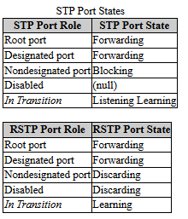

The characteristics of RSTP port states are as follows:
Port State | Description
Discarding | This state is seen in both a stable active topology and during topology synchronization and changes. The discarding state prevents the forwarding of data frames, thus “breaking” the continuity of a Layer 2 loop.
Learning | This state is seen in both a stable active topology and during topology synchronization and changes. The learning state accepts data frames to populate the MAC table to limit flooding of unknown unicast frames.
Forwarding | This state is seen only in stable active topologies. The forwarding switch ports determine the topology. Following a topology change, or during synchronization, the forwarding of data frames occurs only after a proposal-and-agreement process.

Activity

Step 1: Enable RSTP on all switches (SW1, SW2, and SW3).
On the SW1, SW2, and SW3 switches, enter the following commands:
SW1(config)# spanning-tree mode rapid-pvst
SW2(config)# spanning-tree mode rapid-pvst
SW3(config)# spanning-tree mode rapid-pvst

If all switches in the network, except 1, are running RSTP, the interfaces that lead to legacy STP switches will automatically fall back to nonrapid STP. If you are using Cisco switches, they will fall back to PVST+. You can check whether all the switches have RSTP configured by observing the convergence time.

Step 2: Verify that RSTP is enabled on all three switches (SW1, SW2, and SW3).
On the SW1, SW2, and SW3 switches, enter the following commands:
SW1# show spanning-tree

SW2# show spanning-tree

SW3# show spanning-tree

Step 3: Verify the interface states on all three switches (SW1, SW2, and SW3).
On the SW1, SW2, and SW3 switches, enter the following commands:
SW1# show spanning-tree

SW2# show spanning-tree

SW3# show spanning-tree

RSTP Topology Changes

For RSTP, a topology change occurs only when a nonedge port transitions to the forwarding state. A loss of connectivity is not considered as a topology change, which is different from STP.

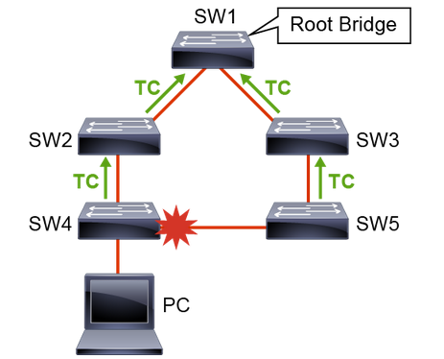
Topology change = a nonedge port changes its state to the forwarding state
All switches can send BPDUs, not just the root bridge.

A switch announces a topology change by sending BPDUs with the TC (Topology Change) bit set out from all the nonedge designated ports. This way, all the neighbors are informed about the topology change, so they can correct their bridging tables.

In the figure, SW4 sends BPDUs out of all its ports after it detects a link failure. SW2 then sends the BPDU to all its neighbors, except the 1 that received the BPDU from SW4, and so on.

When a switch receives a BPDU with the TC bit set from a neighbor, it clears the MAC addresses that were learned on all its ports, except the 1 that receives the topology change. The switch also sends BPDUs with the TC bit set on all designated ports and the root port.

RSTP no longer uses the specific TCN BPDU (Topology Change Notification BPDU) unless a legacy bridge needs to be notified.

With RSTP, the TC propagation is now a 1-step process. In fact, the initiator of the topology change floods this information throughout the network, as opposed to 802.1D, where only the root does. This mechanism is much faster than the 802.1D equivalent. There is no need to wait for the root bridge to be notified and then maintain the topology change state for the whole network for <max age + forward delay> seconds. In just a few seconds, or a small multiple of hello-times, most of the entries in the CAM tables of the entire network (VLAN) flush. This approach results in potentially more temporary flooding, but on the other hand, it clears potential stale information that prevents rapid connectivity restitution.

Why does RSTP not consider link failure a topology change? Loss of connectivity does not provide new paths in the topology. If a switch loses the link to a downstream switch, the downstream switch either has an alternate path to the root bridge or it does not. If the downstream switch has no alternate path, no action will be taken to improve convergence. If the downstream switch has an alternate path, the downstream switch will unblock it and so generate its own BPDUs with the TC bit set.

Like with STP, PortFast-enabled ports do not create topology changes, which reduce the amount of topology change messages flooding. PortFast-enabled ports do not have associated MAC addresses that are flushed if a topology change message is received.

Step 4: Shut down the interface GigabitEthernet 0/2 on SW3 and observe the convergence time of RSTP.
If you want to observe the port state recalculation, you must trigger a topology change. One of the options is to shut down the interface.
How much time will it take spanning tree to converge now that you have enabled the rapid version?
On the SW3 switch, enter the following commands:
SW3(config)# interface GigabitEthernet 0/2
SW3(config-if)# shutdown

Step 5: Verify the interface states on all three switches (SW1, SW2, and SW3).
On the SW1, SW2, and SW3 switches, enter the following commands:
SW1# show spanning-tree

SW2# show spanning-tree

SW3# show spanning-tree

Interface E0/2 on SW3 is no longer listed because it is no longer enabled.
RSTP Link Types
Link types provide a categorization for each port participating in RSTP.

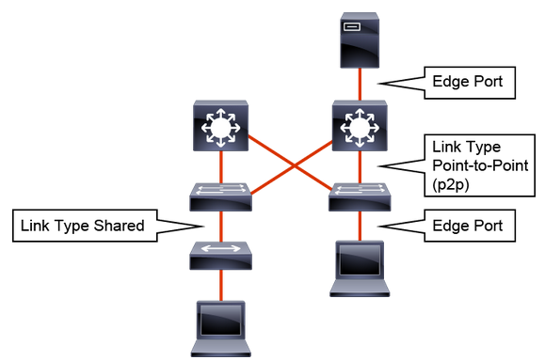

The link type can predetermine the active role that the port plays as it stands by for immediate transition to a forwarding state. These parameters are different for edge ports and nonedge ports. Nonedge ports are categorized into two link types.

Link Type | Description
Point-to-point | Port operating in full-duplex mode. It is assumed that the port is connected to a single switch device at the other end of the link.
Shared | Port operating in half-duplex mode. It is assumed that the port is connected to shared media where multiple switches might exist.

The link type is automatically determined but can be overwritten with an explicit port configuration.

An edge port is a switch port that is never intended to be connected to another switch device. Edge ports, the equivalent of point-to-point links, are candidates for rapid transition to a forwarding state. Before the link type parameter can be considered for expedient port transition, RSTP must determine the port role.

At this point, there is a user-configured value and an operational value for the edge port state. The Cisco implementation maintains that the PortFast keyword be used for edge port configuration. This makes the transition to RSTP simpler.

Root ports do not use the link type parameter. Root ports are able to make a rapid transition to the forwarding state when the port is in the sync state.

Usually, alternative and backup ports do not use the link type parameter.

Designated ports make the most use of the link type parameter. Rapid transition to the forwarding state for the designated port occurs only if the link type parameter indicates a point-to-point link.

You can verify the port type by issuing the show spanning-tree command.

Step 6: Manually configure the link between SW1 and SW3 as a point-to-point link.
On the SW1 and SW3 switches, enter the following commands:
SW1(config)# interface GigabitEthernet 0/1
SW1(config-if)# spanning-tree link-type point-to-point

SW3(config)# interface GigabitEthernet 0/3
SW3(config-if)# spanning-tree link-type point-to-point

Step 7: Using the show spanning-tree command, verify the link type for the link between SW1 and SW3.
On the SW1 and SW3 switches, enter the following commands:
SW1# show spanning-tree

SW3# show spanning-tree

The link type for the link between SW1 and SW3 should now be point-to-point.

